Risk Assessment Report – ALE & Risk Matrix

1. Objective
This report demonstrates the calculation of Annualized Loss Expectancy (ALE) and the evaluation of risk using a 5x5 risk matrix for a ransomware scenario.

2. ALE Calculation
The Annualized Loss Expectancy (ALE) was calculated using the formula:
ALE = SLE × ARO
Where:
- SLE (Single Loss Expectancy) = $10,000
- ARO (Annual Rate of Occurrence) = 0.2
Therefore:
ALE = 10,000 × 0.2 = $2,000
This means the expected annual loss due to ransomware is $2,000.
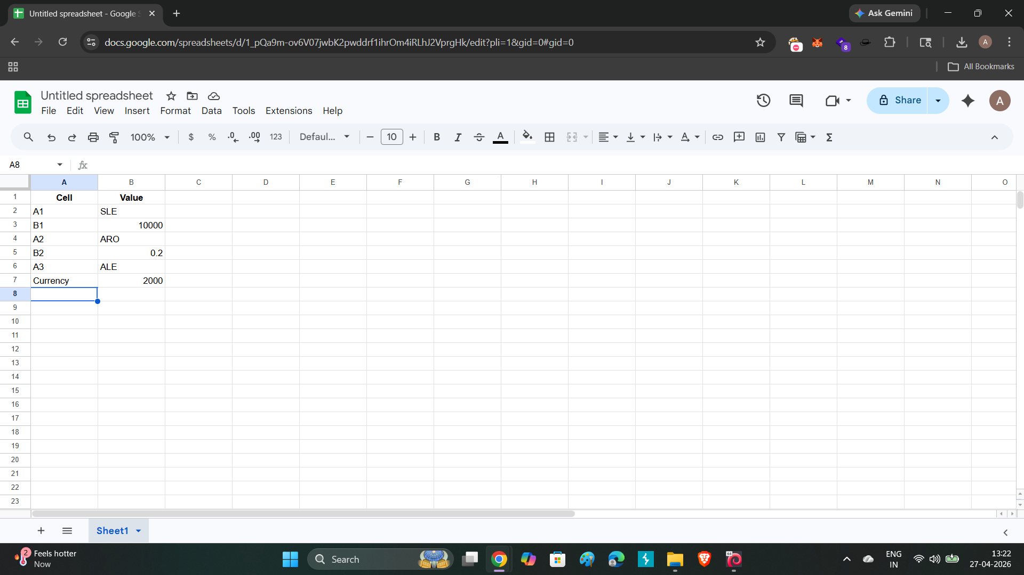

3. Risk Matrix Analysis
A 5x5 risk matrix was used to evaluate the ransomware scenario based on likelihood and impact.
- Likelihood = 2 (Low probability)
- Impact = 4 (High impact)
Risk Score = Likelihood × Impact = 2 × 4 = 8
This places the risk in the Medium category.

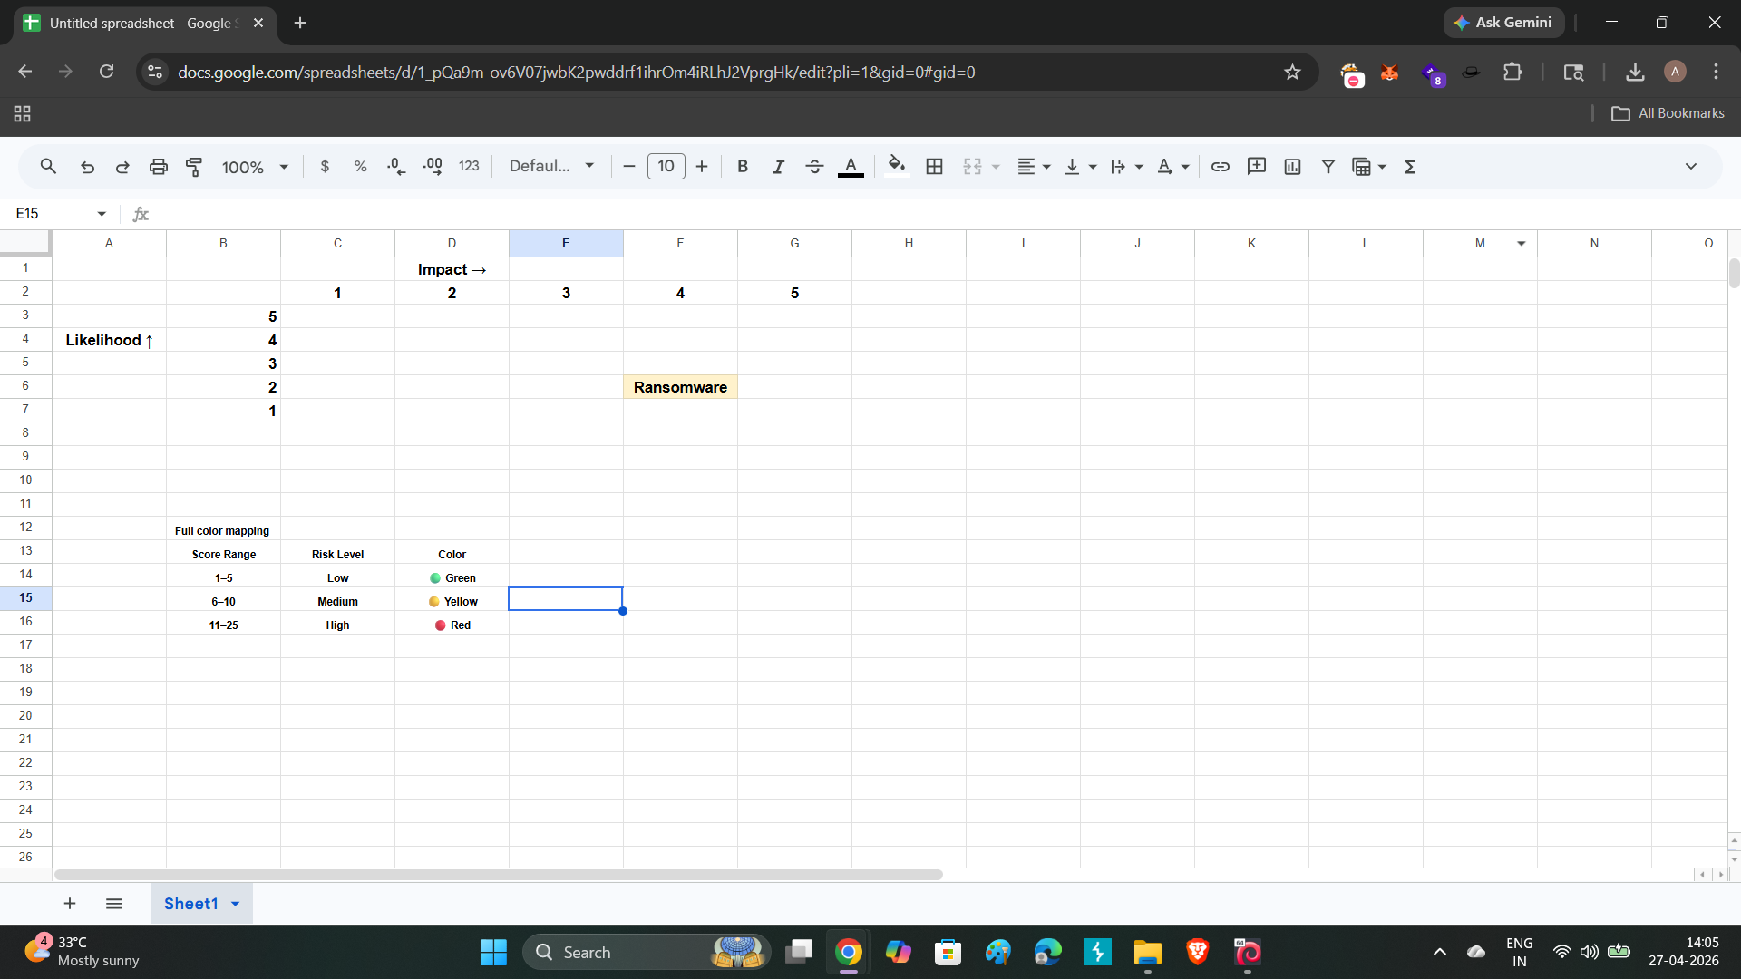

4. Risk Level Classification
The following risk levels were used:
- Low Risk (1–5): Green
- Medium Risk (6–10): Yellow
- High Risk (11–25): Red
The ransomware scenario falls under Medium Risk (Yellow).

5. Conclusion

The risk assessment shows that while ransomware may not occur frequently, its impact is significant. Organizations should implement preventive and detective controls to reduce the likelihood and impact of such threats.

